Daniel Williamson

Project #3

3/17/17

EE 222

Project Overview

Purpose:

The purpose of this project was to solve a user selected sized maze. Essentially, it will take in two parameters, the length and height of the maze which must be in odd numbers. Once you have the size, our logic needs to be applied correctly to solve said maze. Our assignment was for us to fill in the functions provided to appropriately do what it needs to do. Once we have passed the provided unit tests. We run the program to print out a maze and then print out the solved maze.

Approach:

To begin, I needed to understand what the files were provided were doing. Your instructions, to me, were unclear and hard to understand. After discussing with some peers, I finally got an understanding on how to run the unit tests and what was needed of me to complete the project. Once everything was set up and running correctly I could put my code into the areas provided. Starting with the TurnRight function. I went down each function from there, passing each test as I went. After passing all four tests, I went onto included the logic in the main function to traverse and print out the maze.

Results:

This is a photo of passing all the unit tests:

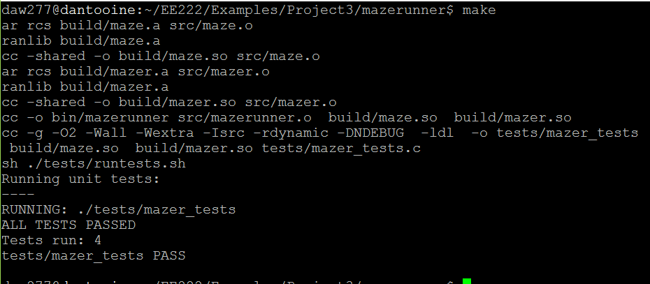

After passing all those, I had it traverse and print out the maze. I created a 41X21 maze to run.

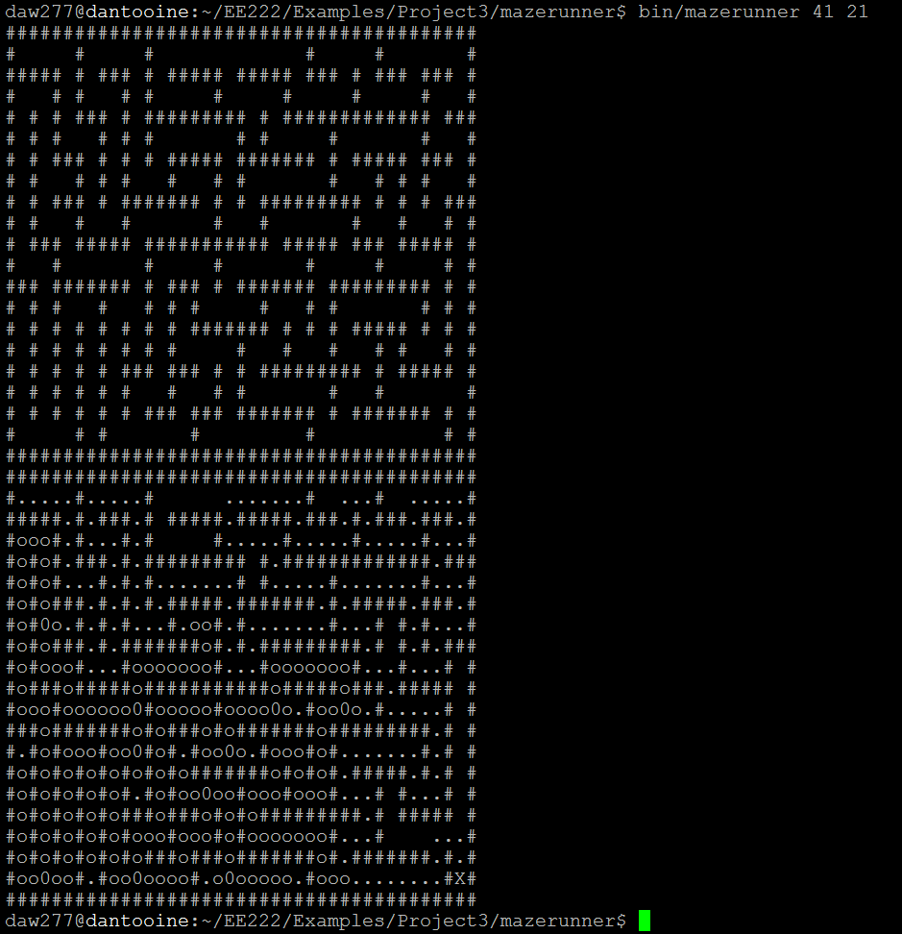

And here is it completing the 71X21 maze:

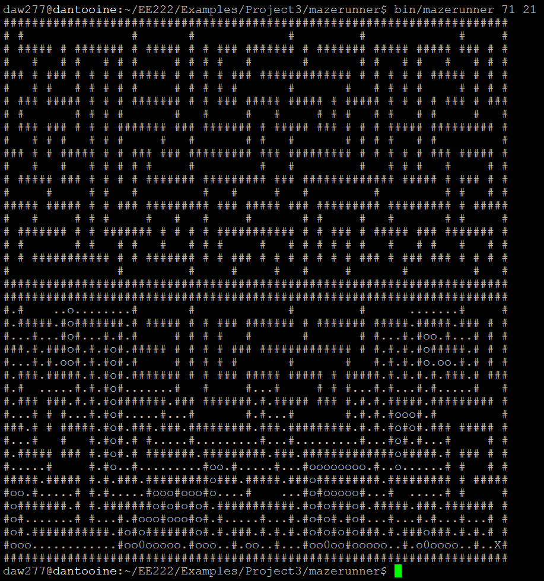

Conclusion:

In conclusion, this was a rather easy lab. Except for getting it up and running. Very confusing for me. Other than that, all the logic is rather easily followable. And you gave us the logic for running and finding the mazes end.